Cloud Computing CAT-2 Project

SUBIKA. T – 1934050

RAJALAKSHIMI. C – 1934030

We have created an application which displays the time of call and tried to deploy the same using docker and kubernetes.

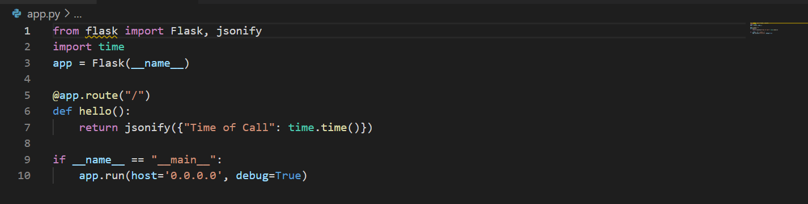

**Mentioning the required dependency in a text file.**

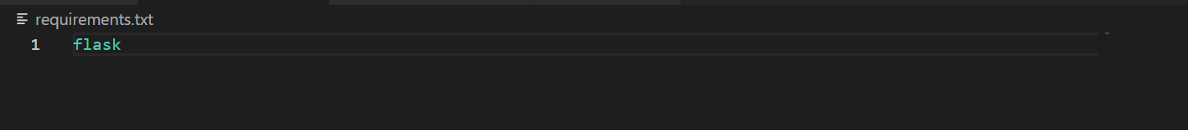

**Creating Dockerfile.**

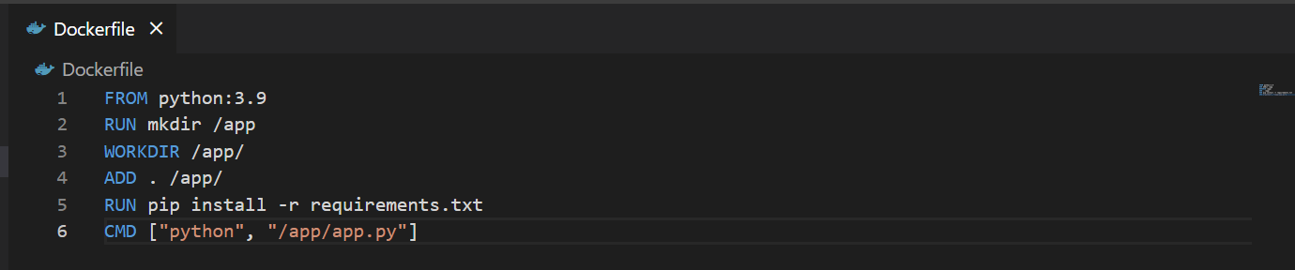

FROM is used to pull the app python 3.9 then, creating a new directory inside the container and working directory app just to install application. ADD will copy the contents in kubernetes directory to app directory. RUN command will install the dependencies mentioned and finally running the command app.py to start the server.

**Building docker image:**

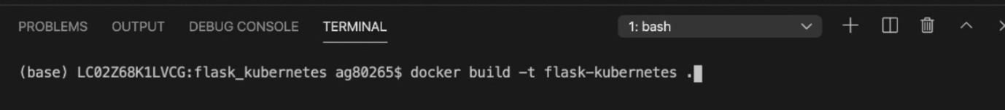

Now the docker image is successfully built. We can also check that using the command **docker images**

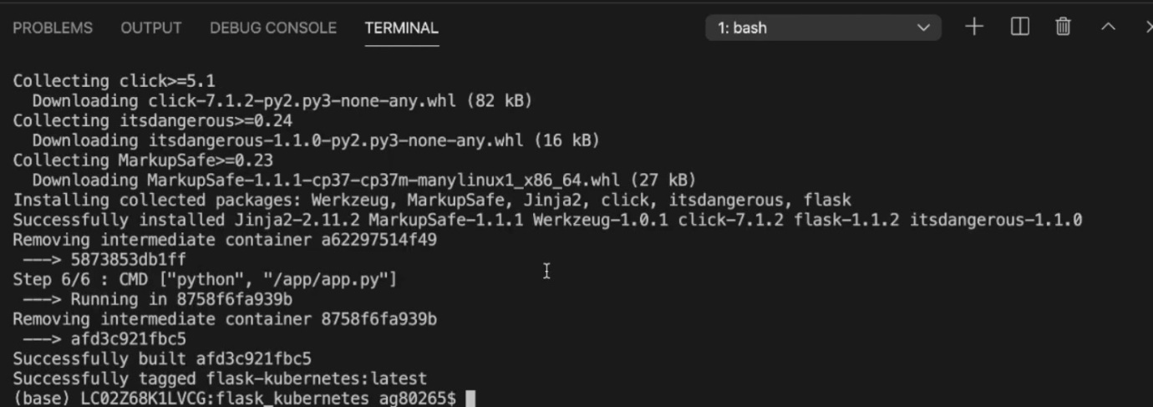

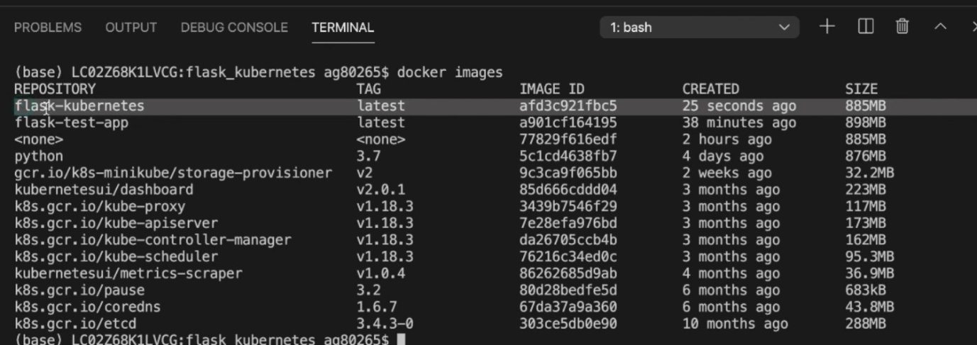

**Creating Deployment.yaml file:**

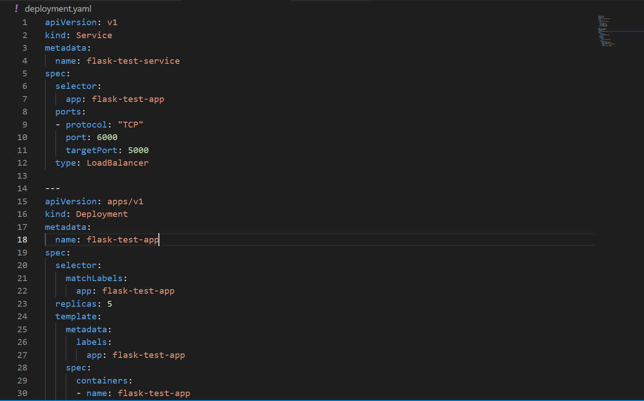

The file has two parts service and deployment. Service works as load balancer and deployment serves as applications. We use 5 instances for scalability purpose, so that if one instance crashes the other instances will serve as an application. This file is connected to the docker image which was created previously, so that while deploying it the containers are automatically created based on the docker image.

**Deploying Containers:**

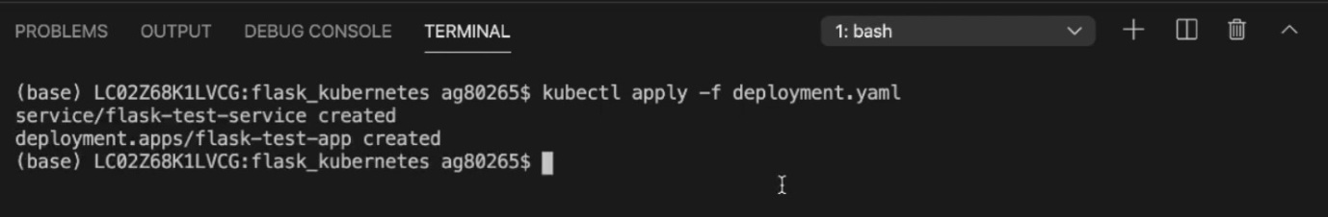

**Namespace and Pods:**

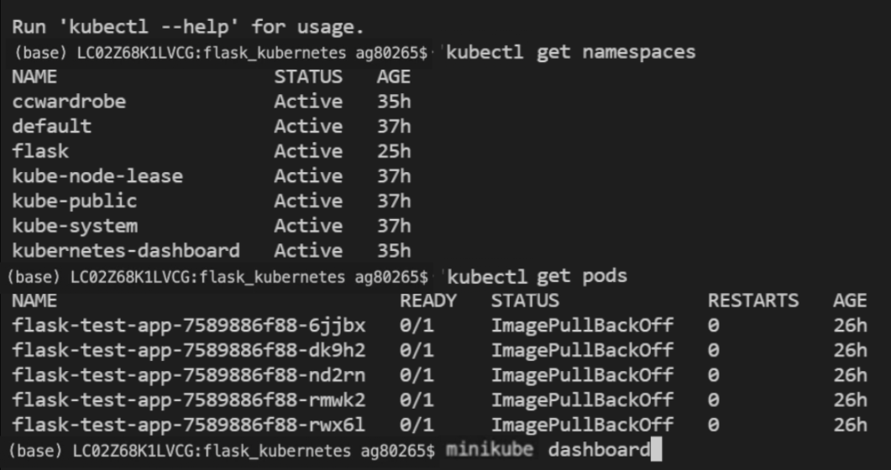

**Viewing the application in minicube dashboard:**

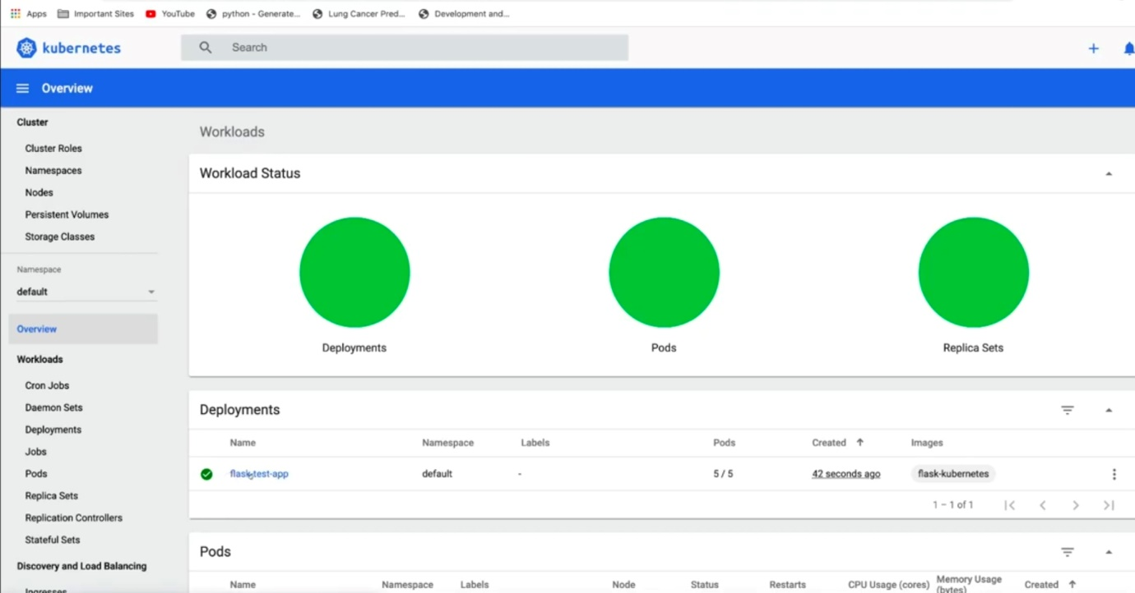

**As we can see 5 Pods are deployed inside a default Namespace**

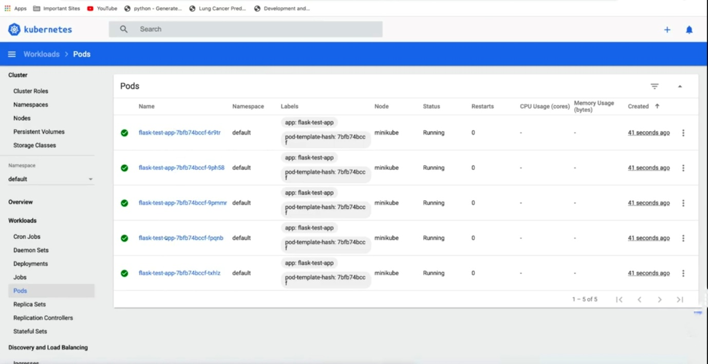

**Service Exposure:**

